We ask that you read through this document in its entirety. Any edits or revisions must be submitted within 48 hours.

Title: 5 Books Every Game of Thrones Fan Should Read
Description: Game of Thrones fans are sure to feel lost once the final season of the HBO series ends. To keep boredom at bay, we list 5 books you must read if you love GoT.
H1: 5 Books Every Game of Thrones Fan Should Read
Content:
Citation:©[LoloStock]/Adobe Stock
Winter is here… or at least the final season of Game of Thrones is. The HBO television series is a favorite of millions of fantasy fans around the world—but with the series ending next month and no release date for George R.R. Martin’s next book in sight, fans of the series may feel lost. Fortunately, there are several other remarkable fantasy series for us to enjoy. We created a list of five books that are must-reads for Game of Thrones fans.

1. The Mists of Avalon
By Marion Zimmer Bradley
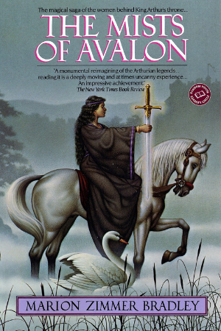
https://www.amazon.com/Mists-Avalon-Marion-Zimmer-Bradley/dp/0345350499
This book is a unique retelling of the Arthurian fable, following the legendary figure through the eyes of Camelot’s women. The tale beautifully weaves together strong characters and intricate lore, recounting the roles of Morgana, Gwenhwyfar, Viviane, and Morgause in the fight for Camelot.

2. The Waking Fire
By Anthony Ryan
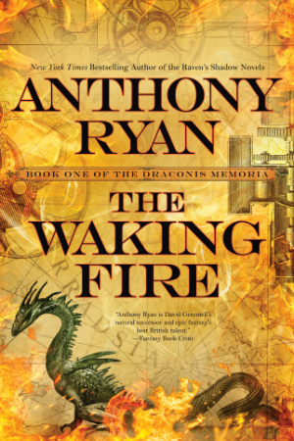
https://anthonyryan.net/books/the-waking-fire/
The first book in the Draconis Memoria series, The Waking Fire tells of a world at the brink of war. The only thing keeping war at bay is the blood of drakes (dragons), which can be filtered and turned into powerful elixirs. Secretly, however, the drake line is dying out—the world’s only chance of survival is a hidden breed of drake rumored to be more powerful than the rest. If it can be found, then perhaps peace is possible yet.

3. Sorcerer to the Crown
By Zen Cho
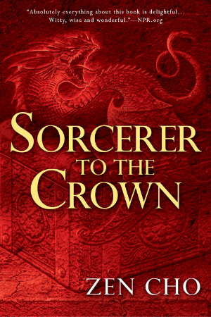
https://www.amazon.com/Sorcerer-Crown-Novel/dp/0425283402
When Zacharias Whythe is named Sorcerer Royal, England’s magic supply begins rapidly decreasing. Word spreads that the reason is because Zacharias is unfit for his position, so he sets out to discover the cause of the magic’s depletion. He crosses paths with an unusual woman named Prunella Gentlewoman and soon realizes that her power is unlike anything England has ever seen before.

4. The White Queen
By Philippa Gregory
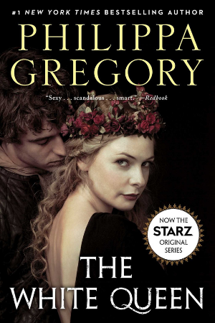
https://www.amazon.com/White-Queen-Plantagenet-Tudor-Novels/dp/1476735484
Game of Thrones often parallels events from our own history—specifically, the Tudor dynasty. Similarly, The White Queen tells the story of Elizabeth Woodville, who creates a scandal when she enters a politically unequal marriage with King Edward IV. Despite the outrage in the English court, Elizabeth is determined to prove her worth.

5. The Lies of Locke Lamora
By Scott Lynch
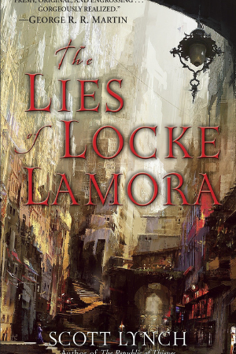
https://www.amazon.com/Lies-Locke-Lamora-Gentleman-Bastards/dp/055358894X
When a talented con artist takes the orphaned Locke Lamora under his wing, Locke soon becomes the leader of a band of thieves known as the Gentleman Bastards. Despite Locke’s newfound infamy, a man even more zealous than he emerges from the criminal underworld—and he proves to be a deadly threat. A dangerous game begins, and Locke’s life is not the only one at stake.

